CTP preparedness self-assessment template

Introduction
The cash transfer programming (CTP) preparedness self-assessment tool is the starting point for a National Society to document its current operational readiness, capacity and gaps in implementing CTP for emergencies rapidly and at scale. This process will serve as a learning process to extract recommendations and to identify priority areas for development in CTP preparedness within the National Society.
The self-assessment tool is based on four parallel tracks identified in RCM’s Cash Transfer Programming: Guidelines for mainstreaming and preparedness, which is ideally used in conjunction with this tool. Each of these tracks are equally essential and contributes to the operational readiness capacity of the National Society:
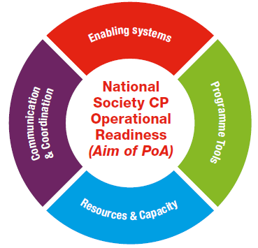
- Enabling systems
- Programme tools
- Resources and capacity
- Communication and coordination
Prioritization of activities will depend on the National Society’s own unique profile, but all four tracks will eventually need to be developed to reach real operational readiness. A more detailed explanation of the four tracks can be found in Table 1.
This tool aims at guiding National Societies to conduct their own self-assessment of capacities and needs to identify the required preparedness measures to reach the necessary capacity to implement CTP faster and at larger scale. It is recommended that this self-assessment is:
- facilitated and supported by someone (within or outside the National Society) with CTP expertise;
- a participatory process involving key staff from all relevant departments (programming and support services);
- owned by the National Society
The final outcome of the self-assessment is not intended to be compared between National Societies but, instead, to be used as a baseline in order to assess progress in the four key areas within the National Society. This self-assessment can be undertaken and repeated at any point in time to gain a snapshot of a National Society’s current CTP readiness.

Process
The NS cash and vouchers capacity self assessment process can be part of the cash preparedness initiative and should be part of a wider preparedness activity and therefore, iterative, as the preparedness activities evolve over time.
The self-assessment process | Main activities
1. Assemble key stakeholders | - Identify a group of technical, management and support functions for FbF CVA
2. Schedule and plan for workshop | - Secure appropriate venue for a one-two day workshop  - Send invitations to the key stakeholders far in advance to secure availability  - Ensure the workshop facilitator is someone with CTP expertise
3. Conduct workshop | - Develop Early Action CVA scenarios  - Discuss and gain consensus on the assessment scores  - Graph and present back the assessment scores to the group  - Propose a range of activities to help strengthen their CTP capacity based on the assessment outcomes
4. Develop PoA | - Prioritize and detail the actions  - Present the draft PoA to National Society’s leadership for approval  - Follow-through with PoA by implementing the PoA, incorporating it into internal plans, using it for a funding proposal, etc.

If this is done in part with the RCM’s Cash Transfer Programming: Guidelines for mainstreaming and preparedness, this tool is used as part of section 3.2 Preparedness gap analysis and self assessment.

Table 1. The four parallel tracks that contribute to National Society CTP readiness
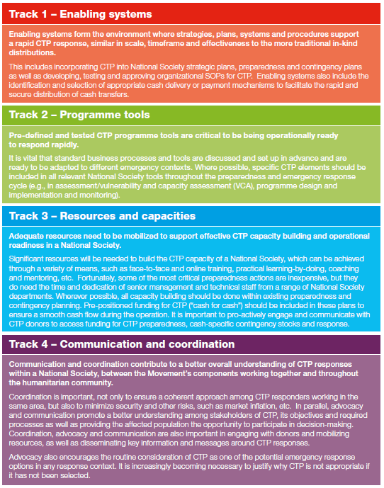

The self-assessment process

1. Assemble key stakeholders
The methodology begins by assembling key stakeholders, which should represent a cross-section of National Society’s programming and support services staff (e.g. disaster management, finance, logistics, organizational development, etc.). The combination of technical, management and support functions is designed to promote dynamic exchanges, shared learning, and a thoughtful consideration of evidence.
It is likely that many of these members will form part of the CTP technical working group which is essential in the next steps of CTP preparedness in order to be able to take decisions and be accountable for those decisions.
See section 4.2 in RCM’s Cash Transfer Programming: Guidelines for mainstreaming and preparedness for further details on establishing a CTP technical working group.

2. Schedule and plan for workshop
This tool guides a facilitated conversation, consensus-based and participatory self-assessment process. It is designed to assess the capacities and needs of a National Society when it comes to preparedness for CTP. It is critical to build ownership and engagement from key stakeholders and to set aside enough time for proper discussions in the self-assessment process. Therefore, it is recommended to set aside one or two days to allow sufficient time for meaningful discussions.
A level of senior management support to CTP preparedness is assumed to be in place prior to this self-assessment process. This ensures that the right structures, people, equipment and agreements are in place or can be established. If this is not yet in place, it is recommended that an initial workshop/presentation to senior management introducing the basics of CTP and explaining its relation to existing National Society strategies and plans first be held for advocacy and awareness-raising.
See section 3.1 in RCM’s Cash Transfer Programming: Guidelines for mainstreaming and preparedness for further details on building stakeholder engagement in CTP preparedness.

3. Conduct workshop
It is useful for the National Society to define what ‘rapid’ and ‘at scale’ means in an emergency to develop a realistic scenario to inform the aspired level of CTP preparedness and the necessary measures towards that scenario. While it’s good to set an aspirational scenario, be specific and realistic on the types of scenario and what type of CTP should be considered/needed to ensure relevancy. Again, as this is an iterative process, what a National Society defines as ‘rapid’ and ‘at scale’ now may change as the National Society progresses.
If this is done in part with the RCM’s Cash Transfer Programming: Guidelines for mainstreaming and preparedness a scenario should have already been developed in Step 2 and can be used to inform this process.

In order to assess the level of preparedness, a set of discussion questions grouped by the four fundamental tracks is given for the group to answer. Depending on the size of the workshop, it may be advisable to break off into smaller groups to allow more in-depth discussions. Thorough discussions and reviewing of evidence, ensure that a consensus score (see table 1) is given to reach an overall score for each track. When appropriate, evidence should be collected to justify the scoring. It can include, but is not limited to, written documentation. Evidence can also be anything observable that is linked to capacity-building efforts: processes; infrastructure; capable people contributing to the achievement of a National Society’s mission; and tangible results of activities are all, potentially, observable evidence.
Table 1. Scoring process
Score | Current status
Nothing done | Nothing exists in this area and no progress has been made to develop it
Gap acknowledged/being identified | Gaps are still being identified and/or are acknowledged
Initial steps/commitment | Little exists that is tangible, but the gap is understood and plans are in place to address the gap
Good progress | Substantive work has been done, but further development work is still required
Almost complete/consistent | Almost everything is in place, but there are remaining gaps such as final sign off or management approval
Standard practice/mainstreamed | Tool/policy/people are in place – no further development is required

Graph 1. Sample spider graph

The scores should then be plugged into the complementary scoring template to present the scores as a spider graph to visually see the strengths and gaps. Further details on how to use the scoring template can be found on the ‘instructions’ tab within the excel file.
By presenting the graph and findings to the key stakeholders, the National Society can generate an exhaustive list of activities needed in order to strengthen targeted capacity for CTP.

4. Develop Plan of Action (PoA)
To develop a realistic and achievable Plan of Action, these activities should be detailed, time-bound, with the implementing and monitoring role assigned and with a budget line to ensure funding is available and/or to fundraise against. Considering the range of activities, they can be ranked and prioritized based on which ones are fundamental for the National Society’s particular context and needs, as well as achievable in terms of time and resources.
Whenever possible, the actions and outputs should be aligned to the National Society’s existing contingency and preparedness plans.

See section 4.3 in RCM’s Cash Transfer Programming: Guidelines for mainstreaming and preparedness for further details on developing the CTP preparedness plan of action.

Summary
The process should be part of a wider preparedness activity and is, therefore, iterative as the preparedness activities evolve over time.
The self-assessment process | Main activities
1. Assemble key stakeholders | - Identify a group of technical, management and support functions
2. Schedule and plan for workshop | - Secure appropriate venue for a one-two day workshop  - Send invitations to the key stakeholders far in advance to secure availability  - Ensure the workshop facilitator is someone with CTP expertise
3. Conduct workshop | - Develop scenario  - Discuss and gain consensus on the assessment scores  - Graph and present back the assessment scores to the group  - Propose a range of activities to help strengthen their CTP capacity based on the assessment outcomes
4. Develop PoA | - Prioritize and detail the actions  - Present the draft PoA to National Society’s leadership for approval  - Follow-through with PoA by implementing the PoA, incorporating it into internal plans, using it for a funding proposal, etc.

The CTP preparedness self-assessment questions
Track 1 – Enabling systems
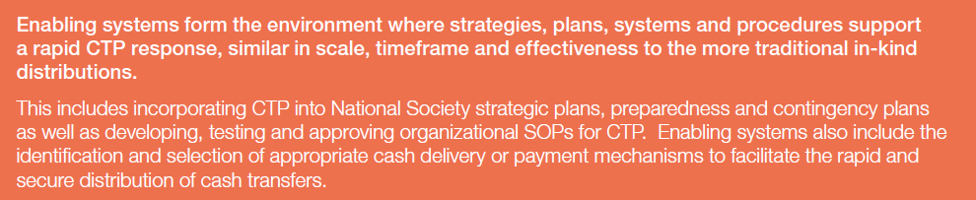

Dimension 1: Vision and strategy
- To what extent is there active support from the National Society senior leadership on CTP?
- To what extent is the overall strategy for CTP institutionalization established?
- To what extent is the adoption of CTP based on credible evidence?
- To what degree is there a plan of action to achieve CTP institutionalization?
- How consistently are cash transfers considered as a response option?

Dimension 2: Organizational structure
- To what extent is there active support from NS NHQ and branches?
- To what extent is the right structure in place to support CTP at all levels (field and HQ)?
- To what extent is there segregation of duties to implement CTP effectively?
- How well are the policy elements related to CTP adhered to?

Dimension 3: Managing processes
- To what extent are standardized processes that enable CTP implementation in place?
- To what extent have the standardized processes been tested?
- To what extent are the standardized processes utilized at all levels (NHQ, chapter, subchapter)?
- To what extent do the processes enable a cost-efficient and effective modality selection?
- How integrated is CTP in the contingency plans?
- How would you rate the current instruments used for cash distribution and reconciliation?

Track 2 – Programme tools
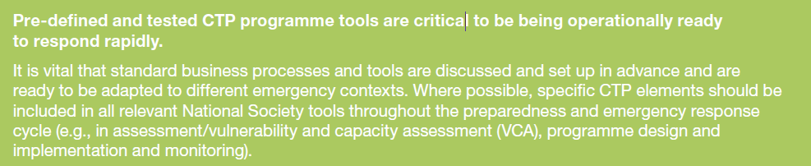

Dimension 1: CTP specific tools
- To what extent do we have CTP tools that have been adapted to our context?
- To what extent have the CTP tools been incorporated into the National Society’s tools throughout the preparedness and emergency response cycle?
- To what extent is our M&E framework capturing the CTP processes?
- To what extent do we analyse and interpret data as it relates to CTP?
- To what extent is there embedded feedback and complaint mechanism to inform and adjust CTP?
- How adequately does the CTP integrate governance and social dynamics considerations (e.g. government policies, gender, protection, disabilities, etc.)?

Dimension 2: Information management
- How well do we develop and manage information on CTP?
- To what extent do we manage to identify new programme opportunities or adjustments for CTP?
- To what extent do we have database and reporting systems to manage our information?
- To what extent do we have embedded feedback and complaint mechanisms to inform and adjust CTP?

Dimension 3: Infrastructure, equipment and technology
- To what extent is there sufficient infrastructure and equipment in place for scaling up CTP?
- To what extent do we have technology that enables our work in CTP?
- To what extent do we have the right technology to register our CTP beneficiaries?
- To what extent does data privacy hinder/slow down CTP implementation?

Track 3 – Resources and capacities
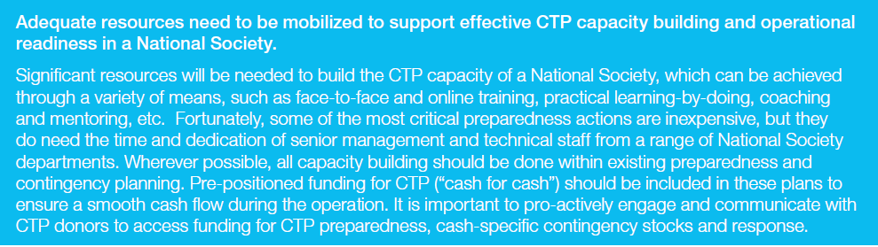

Dimension 1: Resource mobilization and funding
- How do we rank our funding model in terms of enabling our growth in CTP?
- How do we rank our systems for effective fund raising effectively for CTP?
- To what extent are the technical systems and skills in place to manage budgets effectively?
- What is the current ability to make sound and informed cost-efficiency decisions?

Dimension 2: Management and leadership
- To what extent do managers have the right level of engagement and skills to support the institutionalization of CTP?
- To what extent is functional knowledge possessed by managers to guide the organization through CTP institutionalization?
- To what extent do managers have the authority to make timely and informed decisions for CTP?
- To what extent do the technical coordinators/advisors have the right skills for promoting the effective institutionalization of CTP?

Dimension 3: Human resources
- To what extent is there a focal point dedicated to CTP?
- How well do we proactively support knowledge development of CTP within our staff?
- To what extent is our staff confident in CTP at all levels and for each function?
- To what extent are our volunteers confident in CTP at all levels and for each function?
- To what degree do we have the right systems in place to recruit and retain CTP-trained staff?
- To what extent do we have enough critical mass trained in CTP for effective CTP delivery?

Track 4 – Communication and coordination
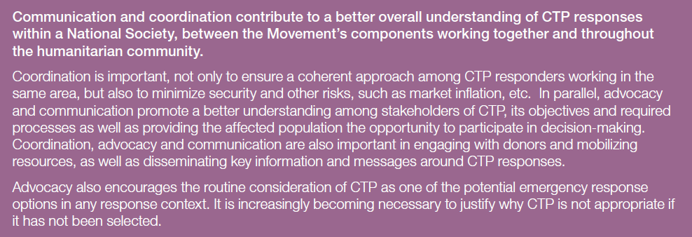

Dimension 1: Advocacy and communication.
- To what extent has there been advocacy work for CTP?
- To what extent do we use the advocacy instruments to mobilize stakeholders in support of CTP?
- To what extent is there a communication strategy in place?
- How well do we communicate internally and externally regarding our objectives in CTP?
- How well do we communicate and coordinate across the organization on CTP?

Dimension 2: Beneficiary communication
- To what extent are the methodologies in place for beneficiary mobilization, verification and follow-up?
- To what extent is there a feedback and learning assessment loop for CTP?
- How well do we communicate effectively with the communities on CTP?

Dimension 3: Coordination and partnerships
- To what extent do we understand other organizations’ use of CTP within our operational context?
- To what extent do we support/participate in informal coordination mechanisms for CTP?
- To what extent do we support/participate in formal coordination mechanisms for CTP?
- How well do we dedicate resources for CTP coordination?
- How effectively do we coordinate government systems while implementing CTP?
- How well do we diversify our range of partners in support of CTP?
- To what extent have we been able to build effective partnerships with businesses for CTP?
- How well do we build effective partnerships with traditional and non-traditional donors for CTP?

Based and adapted from IFRC’s OCAC and CaLP’s CTPOCAT to suit the RCRCM CTP preparedness framework.
ICRC and International Federation of Red Cross and Red Crescent Societies (2015), ‘Cash transfer programming – Guidelines for mainstreaming and preparedness’.

