Roadmap for rapid market assessment baseline
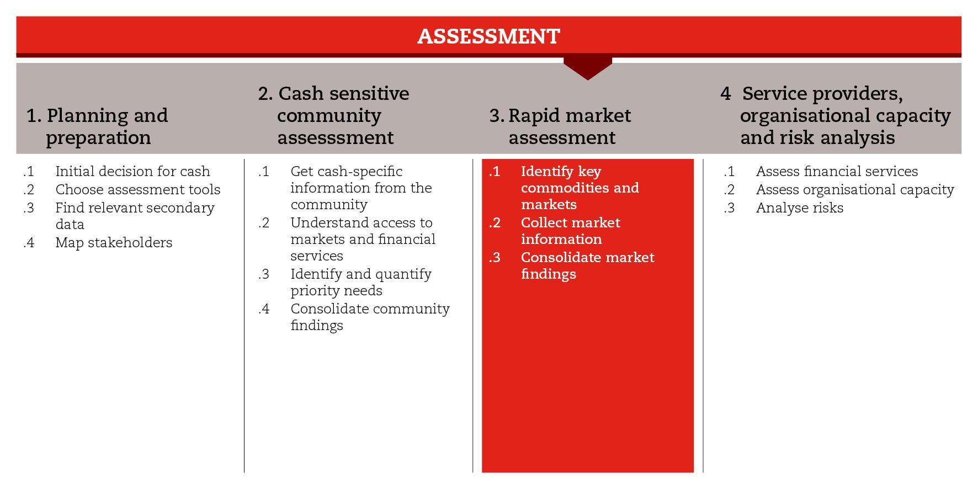

INTRODUCTION
In emergencies, market assessments can help to understand the market capacity to supply the shock-affected population with priority commodities and services. They can also help you understand the risks of potential interventions causing harm and how to support recovery. This road map will assist you to move through the process of conducting a rapid market assessment after a shock.

The rapid market assessment process has been divided into three sub-steps. The first sub-step guides you through the selection of commodities and marketplaces to be assessed. The second sub-step supports the collection and consolidation of relevant information from the selected marketplaces. The third sub-step guides your analysis and conclusions on the market capacity.

The process and tools suggested here have been taken from the Rapid Assessment of Markets (RAM). You can choose to follow the RAM or, if time and resources allow, another in-depth approach, like the Market Assessment Guidance (MAG) or EMMA. In the reference documents suggested at the end of the road map, you will find the RAM guidelines and other market assessment approaches from which you can choose.

MINIMUM STANDARDS
- When conducting a market assessment, adopt a multi-sector approach, focusing on commodities, services and markets that are central to the early action objectives (i.e. households’ priority needs, livelihoods, livestock protection, shelter improvements, etc.)
- Base your analysis on secondary data, and on first-hand information from the target population and other key market informants. Always triangulate the information obtained
- Involve logistics from the early start, logisticians usually have good knowledge of local markets and are used to dealing with traders
- Include questions on how shocks have affected the markets in the past (i.e. impact, availability, access, prices, volume of trade, restocking capacity, etc.)
- Use maps to represent graphically how markets are organized and how they have been affected by the early action related shock in the past
- When drawing conclusions and making recommendations, make clear reference to findings (including risks) on which they are based
- If there is no technical market capacity for leading a market assessment in country, make sure to mobilize required expertise in good time

SUB-STEPS AND TOOLS

Identify key commodities and markets
Conducting a rapid market assessment can be challenging if you do not have the required technical expertise available in your team. Check and ensure you mobilize adequate resources to provide technical support or lead a market assessment in a timely manner; when relevant, coordinating market assessment technical support from the region.
- In order to scope feasibility of FbF CVA early actions, a market assessment baseline should be conducted in a timely manner in advance of seasonally predicted pre-disaster times. Conducting a market assessment baseline in pre-disaster times is easier than doing so during a shock when information changes rapidly. In order to identify key commodities and markets, you can refer to secondary data gathered during planning and preparation (step1), and to information collected from communities and households (step2). You will need to distinguish the markets for basic household needs (food, non food items, etc.) from those filling more sector-specific needs that are linked to your defined early actions (i.e. shelter - NFIs to support adaptation/improvement houses; livestock protection - fodder, livestock transport, animal shelter, etc.). When relevant, should consider market systems related to services or protection (e.g. alternative care, health, transport, etc.), and their relevant tools. Conduct discussions with key market informants to cross-check and complement results.
- Always include questions on how a similar shock have affected the markets in the past (i.e. impact, availability, access, prices, volume of trade, restocking capacity, etc.)

Remember that in order to consider the appropriateness of multipurpose cash grants, the market assessment should take a multi-sector approach to feed in the definition and calculation of a minimum expenditure basket (MEB) and one-off needs of the affected population.

The RCRC RAM Guidelines offers different sub-step tools can be adapted for the purpose of FbF contexts. Among the sub-step tools, you will find a questionnaire for focus group discussions with key market informants, as well as a guide for drawing market maps. Preliminary market maps are extremely helpful for identifying key informants to interview and bottlenecks to be investigated in the field. Market maps are a good way to represent and understand the structure of a market system, and should integrate market information obtained from different sources and adapted when relevant.

Collect market information
Once key commodities and markets have been identified, discussions with key market informants and traders can help you obtain a quick and basic understanding of the market situation, with a focus on the key commodities. Remember that different people interact differently with markets, therefore make sure to apply an age, gender and diversity lens. Consult logisticians, they play an important role in the choice of key market informants with whom to hold discussions, as they know and have contact with local traders (particularly wholesalers).
Among the RCRC RAM Guidelines sub-step tools, you will find numerous questionnaires that can guide your interviews with key market informants and traders, and a set of questions that can help you consolidate the information gathered and draw conclusions at the end of the visit to each marketplace. You will also find a list of questions associated with criteria with which traders should comply in order to take part in voucher programmes.

Consolidate market findings
Use maps to graphically represent how markets are organized and how they have been affected by the early action, or behaviors in the onset of the disaster in the past.
Based on whether or not the different marketplaces have the capacity to supply the shock-affected population with sufficient quantities of key commodities, in a timely manner, you will: i) determine the potential for CVA responses, and ii) make response option analysis recommendations on modality (cash, vouchers, in-kind/service or combination) for consideration during response analysis. When drawing conclusions and making recommendations, make clear reference to findings (including risks) on which they are based.
Consider that your recommendations will need to be challenged by other aspects, such as early action objectives, timeliness, flexibility, scalability, cost-effectiveness and efficiency, organizational capacity, people’s preferences and security issues, which may influence the final decision on the best response option.
Among the sub-step tools, you will find a market decision tree that can help you determine the capacity of the marketplace. The conclusion tree should be used in conjunction with sub-step 2 questionnaires. You will find also a report format for consolidating all the information gathered and the conclusions made throughout the rapid market assessment.

Link
International Red Cross Red Crescent Movement (2013) Rapid assessment for markets (RAM): Guidelines for an initial emergency market assessment

Rapid Assessment for Markets, International Red Cross Red Crescent Movement, 2013

